

TITLE:-A SIMPLE TEXT EDITOR

(Notepad)

Project Code Overview:-

package notepad;

import java.awt.\*;

import java.awt.event.\*; imported

import java.awt.datatransfer.\*; packages

import java.io.\*;

import javax.swing.JOptionPane;

public class Notepad extends Frame{

//Lines of code

Notepad() {//lines of code}

private void setIcon() {//lines of code}

class mylistener extends WindowAdapter {//linesofcode}

class New implements ActionListener {//lines of codes}

class Open implements ActionListener {//lines of codes}

class Save implements ActionListener {//lines of codes}

class Exit implements ActionListener {//lines of codes}

void ReadFile() {//lines of codes}

class Cut implements ActionListener {//lines of codes}

class Copy implements ActionListener {//lines of codes}

class Paste implements ActionListener {//lines of codes}

class Clear implements ActionListener {//lines of codes}

class UndoClear implements ActionListener {//lines of codes}

class REPEAT implements ActionListener {//lines of codes}

public static void main(String args []){//lines of codes}

}

GUI APPLICATON:-

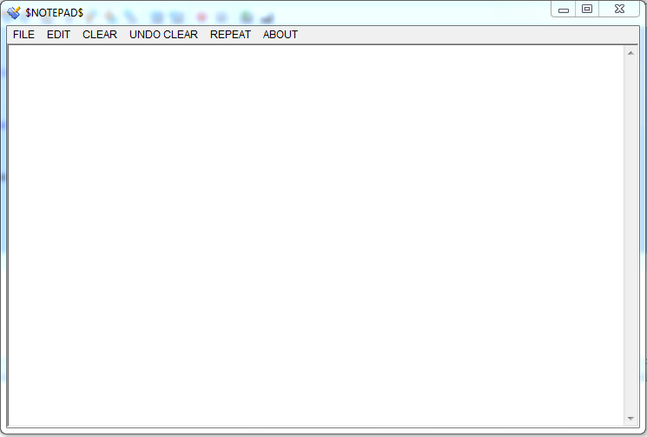

WORKING:-

This project ivery simple to use.their are 6 menu’s out of which 5 can do action and last one is for just displaying information.

I.FILE 2.EDIT 3.CLEAR 4.UNDO CLEAR 5.REPEAT

6. ABOUT

1.FILE:-When we select this option we get 4

Suboptions in it.

1}New:-This will create a new file if clicked.

2}Open:-This will open any existing file in computer if

clicked .

3}Save:-This will save the current editing file in any

desired Location.

4}Exit:-This will help us to exit from Notepad.

2.EDIT:-This menu will let you access 3 basic

Clipboard activities like:-

1}Cut:- It will cut the selected text in Text area.

1}Copy:- It will copy the selected text in Text area.

1}Paste:- It will paste either the copied text or the text

which is cut From the textarea previously .

3.CLEAR:-This will clear entire textarea when we select this

option.

3.UNDO CLEAR:-It will get back the entire texts

In textarea which has been cleared.

5.REPEAT:-This option enable us to repeat any Input message dialog box where user will be asked to input word And number of times the word should be repeated in textarea.

In this gui app we used swing as well as awt packages .